1. Add default gateway for BBB

* From windows ssh to BBB via USB (ip: 192.168.7.2)
* Run below command

|  |
| --- |
| $ sudo /sbin/route add default gw 192.168.7.1 |

1. Setting on windows

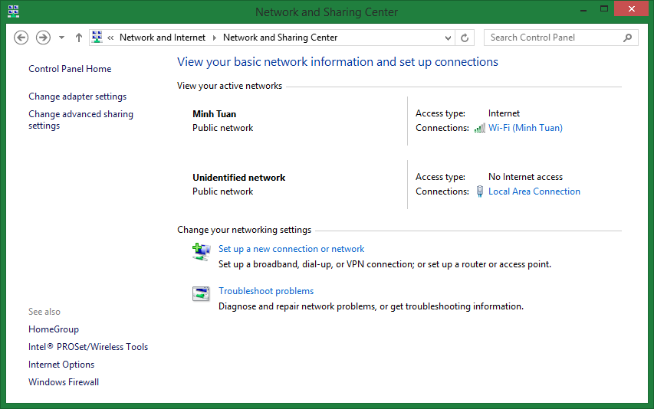

Connection with BBB

Select the internet connection of Windows > Properties > Sharing > Check “Allow other network users to connect through this computer internet connection” > Select connection between Windows and BBB. (in my case it is “Local Area Connection”)

Select Select connection between Windows and BBB (in my case it is “Local Area Connection”). Setting as below

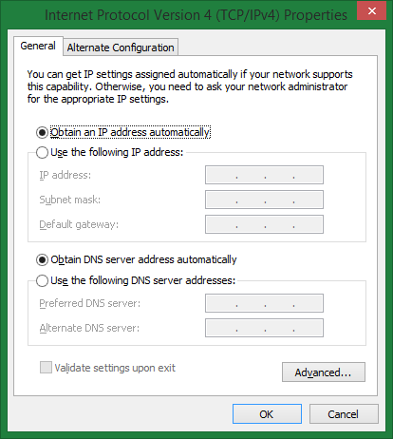

1. Connect to internet from BBB

* Config file resolv.conf

|  |
| --- |
| $ vi /etc/resolv.conf |

Add below lines:

nameserver 8.8.8.8

nameserver 8.8.4.4

* Update

|  |
| --- |
| $ apt-get update |

* Now can install software from internet

|  |
| --- |
| $ apt-get install xinetd tftpd tftp |